Business Question and Visualization Report
Date | 21-Aug-2026
Team ID | Individual
Project Name | India’s Agricultural Crop Production Analysis (1997–2021)
Maximum Marks | 5 Marks

Business Questions and Visualizations
No. | Business Question | Visualization in Your Tableau Workbook | Purpose / Insight
1 | What is the overall agricultural production in India? | India Agricultural Summary – KPI Cards | To understand the overall Area, Production, and Yield.
2 | Which states have higher agricultural production? | State-wise Agricultural Production Distribution – Map | To compare agricultural production across Indian states.
3 | How does total agricultural production change year-wise? | Year-wise Total Agricultural Production – Bar Chart | To identify production trends from 1997 to 2021.
4 | What is the trend of agricultural yield over the years? | Trend of Agricultural Yield – Line Chart | To analyze changes in agricultural yield over time.
5 | How does cultivated area vary across different crops? | Comparison of Cultivated Area by Crop – Horizontal Bar Chart | To compare cultivated area among different crops.
6 | How does cultivated area compare across states? | State-wise Cultivated Area Comparison – Bar Chart | To identify states with higher and lower cultivated areas.
7 | Which state has the highest agricultural production? | Leading State by Agricultural Production – Bar Chart | To identify the leading states based on agricultural production.
8 | How is agricultural production distributed across seasons? | Season-wise Agricultural Production Share – Pie Chart | To understand the contribution of different seasons to total production.
9 | How is production distributed by unit type? | unit type?  Production Distribution by Unit Type – Donut Chart | To compare production across different unit types.

1. What is the overall agricultural production in India?
- Visualization: India Agricultural Summary – KPI Cards
- Attributes:
- Measure: Area
- Measure: Production
- Measure: Yield
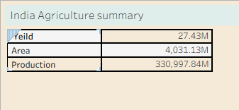
- Category: Agricultural Production

2. Which states have higher agricultural production?
Visualization: State-wise Agricultural Production Distribution – Map
Attributes:
- Dimension: State
- Measure: Production
- Geographical Analysis: State-wise Production
- Comparison :Highvs .Low Production
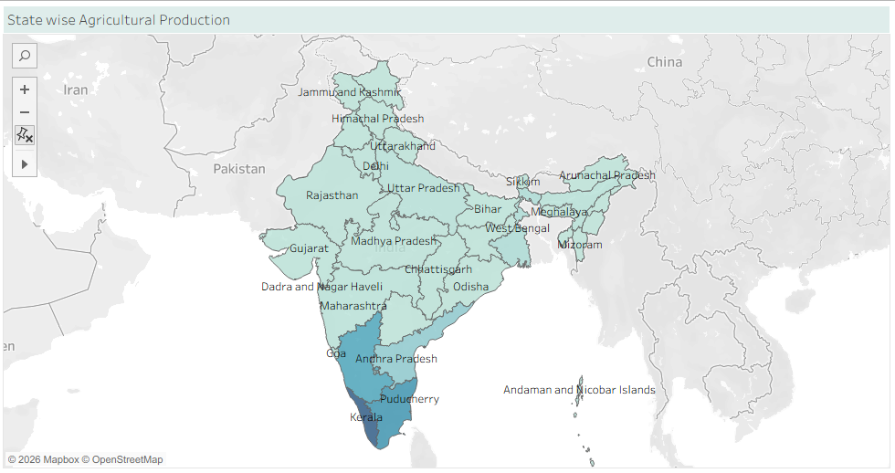

3. How does total agricultural production change year-wise?
Visualization: Year-wise Total Agricultural Production – Bar Chart
Attributes:
- Dimension: Year
- Measure: Production
- Trend: Year-wise Production
- Period: 1997–2021

Screenshot:

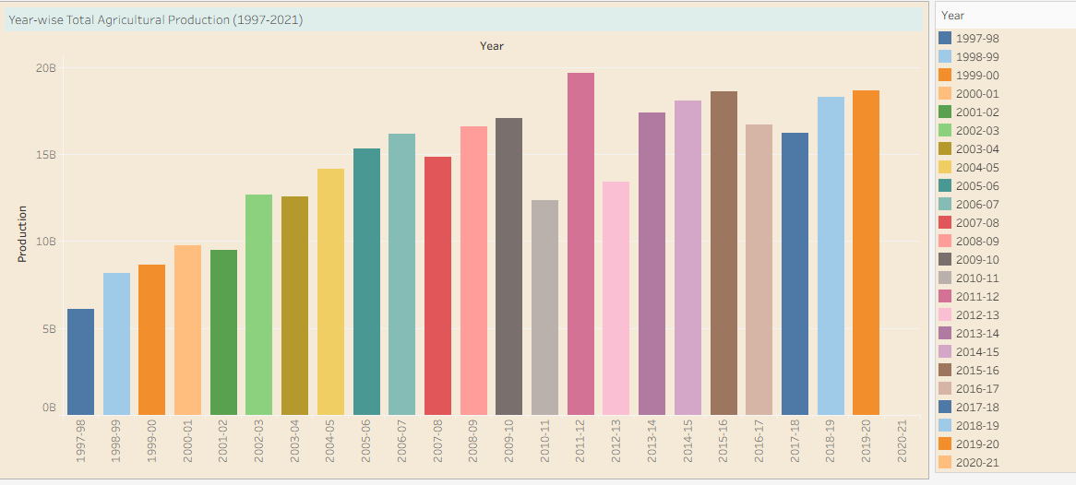

4. What is the trend of agricultural yield over the years?
Visualization: Trend of Agricultural Yield – Line Chart
Attributes:
- Dimension: Year
- Measure: Yield
- Trend: Year-wise Yield

Screenshot:

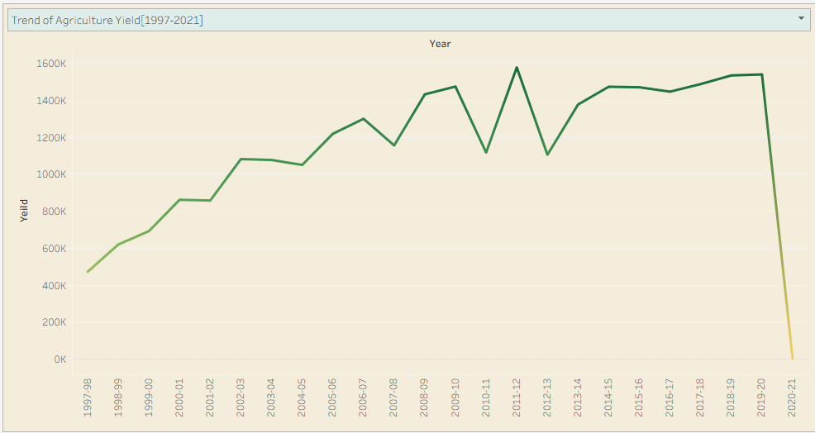

5. How does cultivated area vary across different crops?
Visualization: Comparison of Cultivated Area by Crop – Horizontal Bar Chart
Attributes:
- Dimension: Crop
- Measure: Area
- Comparison: Crop-wise Cultivated Area

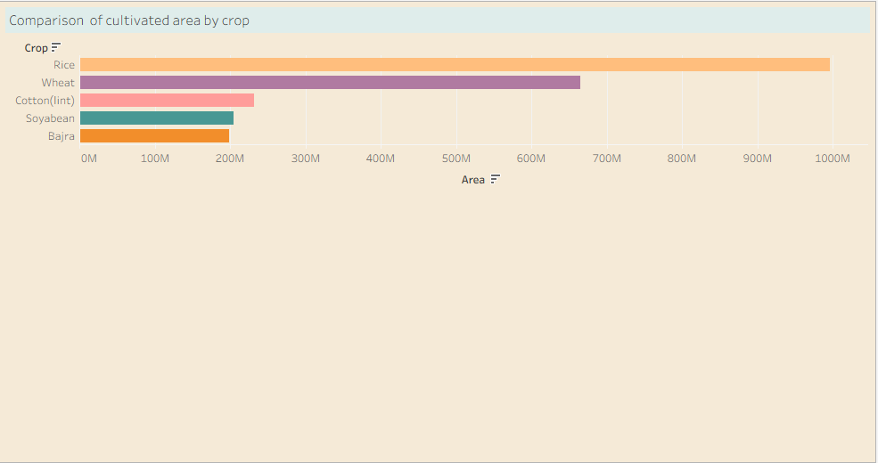

6. How does cultivated area compare across states?
Visualization: State-wise Cultivated Area Comparison – Bar Chart
Attributes:
- Dimension: State
- Measure: Area
- Comparison: State-wise Cultivated Area
Screenshot:
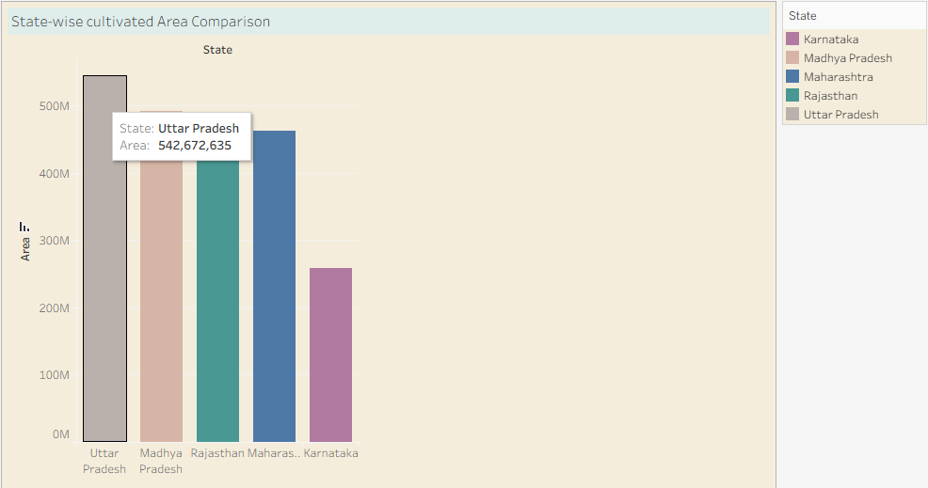

7. Which state has the highest agricultural production?
Visualization: Leading State by Agricultural Production – Bar Chart
Attributes:
- Dimension: State
- Measure: Production
- Ranking: State-wise Production

Screenshot:
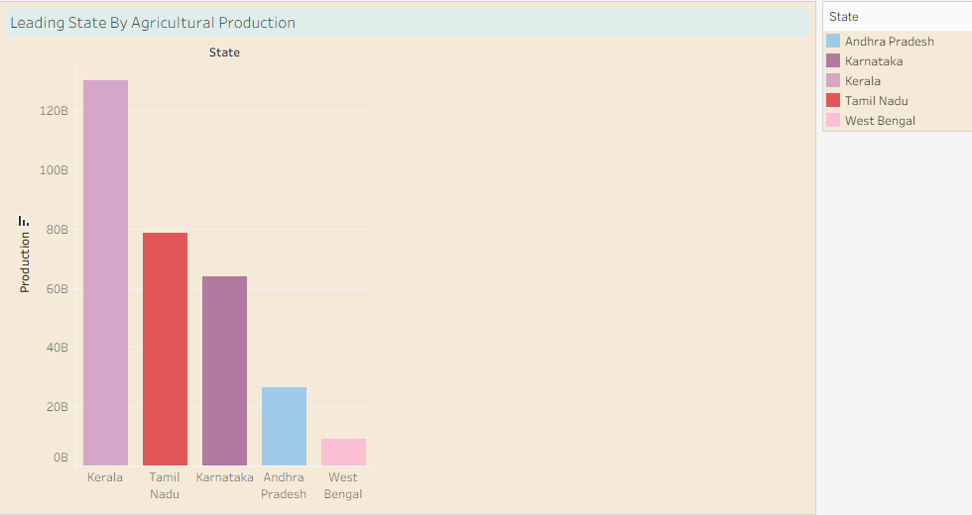

8. How is agricultural production distributed across seasons?
Visualization: Season-wise Agricultural Production Share – Pie Chart
Attributes:
- Dimension: Season
- Measure: Production
- Comparison: Season-wise Production Share

Screenshot:

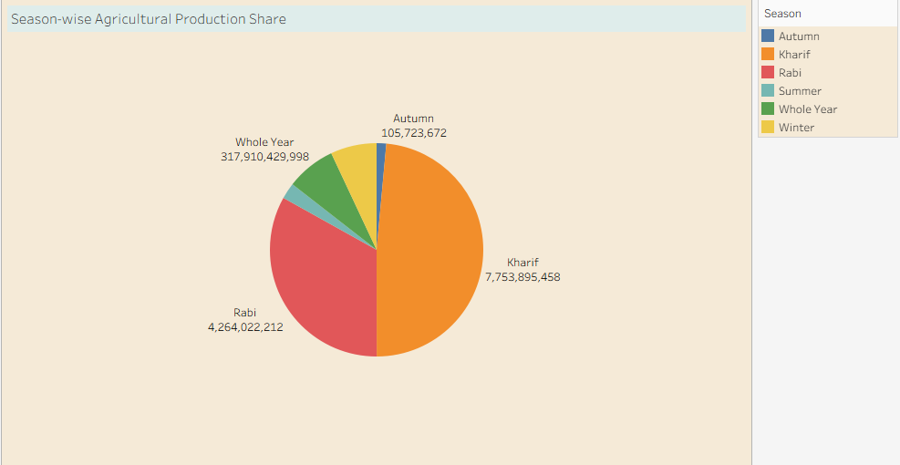

9. How is production distributed by unit type?
Visualization: Production Distribution by Unit Type – Donut Chart
Attributes:
- Dimension: Unit Type
- Measure: Production
- Comparison: Unit-wise Production Distribution

Screenshot :
